DIGITAL MARKETING ASSIGNMENT



**BE – Computer Science and Engineering** Vivekananda College of Technology for Women

Namakkal - 637205

# **NM id: B3F06510CC0EBC5993B4F4A42F3EACD1**

**Submitted By:**

# GAYATHRI A AU613020104019

BRAND NAME:

Classy Art

LOGO:



CATEGORY:

photos and painting Brand

1. **Create a blog or website using Blogspot and WordPress.**

Blogspot: https://tamilpaintingtech.blogspot.com/2023/10/article-for-art.html

WordPress: <https://classyartin.wordpress.com/2023/10/29/classy-art-2/>

1. **Create a New Facebook Business Page and Post one social media poster**

Business Page link: <https://www.facebook.com/profile.php?id=61551215129677&mibextid=ZbWKwL>

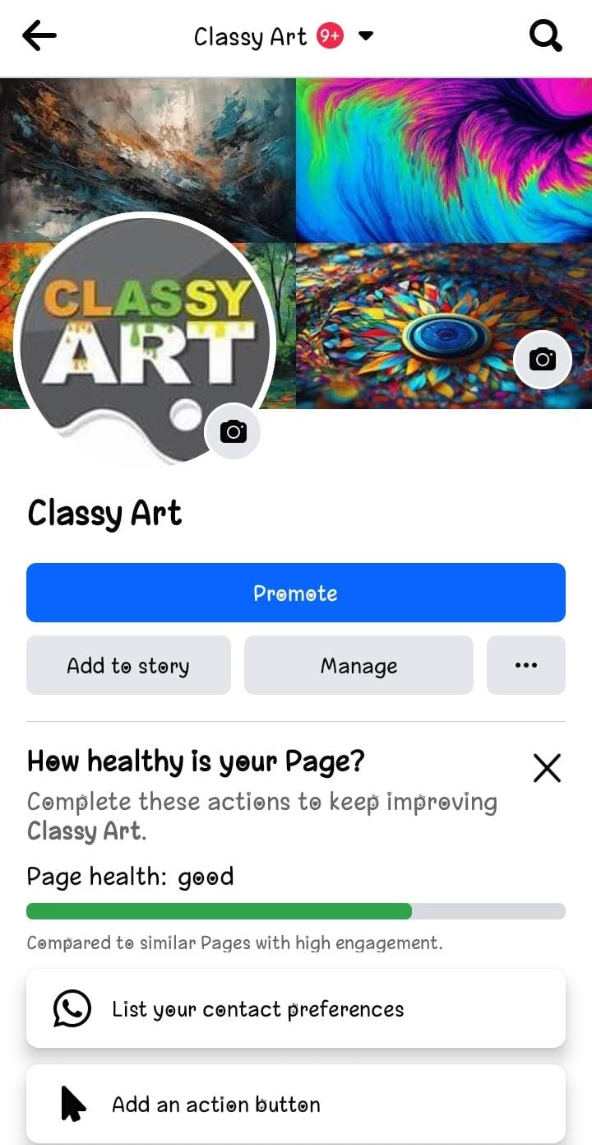

Social media Poster:



1. **Social media advertisement poster using Canva**



1. **Email newsletter using MailChimp or Canva**

